

BHATTADEV UNIVERSITY, ASSAM
Application Form
Ph.D. Programme, ......

Affix a photo

Personal Details:

- Name:

- Programme Applied for: Ph.D. in

3. Category: | UR | OBC/MOBC | SC | ST(P) | ST(H) | UR-EWS | EC

(Please tick whichever is applicable)
4. Gender: | Male | Female | Others

- Date of Birth: (dd/mm/yyyy): / /

- Nationality:

- Religion:

- Domicile State:

- Contact No.

- Email id:

- Aadhaar No.:

12. Marital Status: | Married | Unmarried | Widow | Widower

Parent’s Details:

- Mother’s Name:

- Father’s Name:

Present Address Details:
- Address Line:

- Police Station:

- Post Office:

4. District: |  |  |  |  |  |  |  |  |  |  |  | 5. State:

6. Parent’s Contact No.

Bank Account Details:

- Account Holder Name:

- Bank Name & Branch:

- IFSC Code:

Academic Details:
- Name & Registration No. of the University where registered last (Attach Photocopy of the Registration Certificate): ……………………………………………………………………………………………………
………………………………………………………………………………………………………………….
- Education Information (Attach self-attested photocopies of the Mark Sheets):

Examination Passed | Board/ Council/ University | Year of Passing | % of Marks/CGPA  /Equivalent | Division/ Class | Subjects taken
HSLC or Equivalent
HS or Equivalent
Bachelor’s
Degree
Master’s
Degree
NET/ Gate/ SLET/  Other | Discipline/ Year of Examination/ Score/ Rank  ………………………………………....................................................................................  ................................................................................................................................................

- Academic distinction/ Medals/ Prizes/ Scholarships, if any (Attach self-attested photocopies of certificates)
..............................................................................................................................................................................

..............................................................................................................................................................................

…………………………………………………………………………………………………………………..

(If yes, attach their photocopies)
(Please tick whichever is
applicable)
4. Academic publications in reputed journals: | Yes | No

5. Specific area of interest for doing Ph.D. (Within 100 Words): | ………………………………………….……
…………………….…………………................................................................................................................
………………………………………………………………………………………………………………….

- Experience (Teaching/Research/Any other):

(Mention Organisation, Designation, Assigned Duty, Duration, etc.)
..............................................................................................................................................................................
..............................................................................................................................................................................
..............................................................................................................................................................................

Declaration by the Candidate

I do hereby declare that the information stated above are true to the best of my knowledge and belief.
In case of any false statement, I am liable to any action the University authority may deem fit and proper.

Date:
Place: | Signature of the Candidate

Documents to be Attached with this Form

- SBI Collect Payment Slip of Rs. 1500/- or Rs. 750/-
(Whichever is applicable)

- 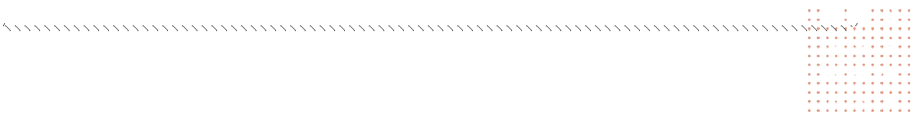Photocopies of all necessary documents wherever “attachments” are requested.

Note
- Submit this application form to the Office of the Academic Registrar on the day of the Entrance Test (for exempted candidates the form may be submitted on the day of personal interview)
- Keep on visiting the university website https://www.bhattadevuniversity.ac.in
- For any query drop mail to admission23@bhattadevuniversity.ac.in

